**Module 3**

* What are the four important tags we use in SEO?
* Meta title tags
* Meta description tags
* Meta keywords
* Meta robot tags
* What tag we will use to add an image to the website? Explain the points we should care about while adding the image to the website.
* The **<img>** tag to embed an image into your web page. This <img> tag has two required attributes: **src** to specify the path to the image, and **alt** to specify an alternate text for the image.
* What is the difference between Nofollow and Noindex?
* **Nofollow** is a HTML attribute that instructs most search engines to refrain from following a link and thereby transfer value to the page linked to. Some SEO experts interpret this as a way of telling search engines that you do not trust or cannot vouch for the content of the link being linked to. So in short, if you do want a search engine to index your web page in search, but you don't want it to follow the links on that page; add a nofollow tag to your page.
* The **Noindex** attribute is used to tell search engines not to index a specific page, meaning that the page will not appear in search engine results. This is useful for pages you don't want to be visible in search results, such as internal pages, duplicate content, or pages that don't provide significant value to users.
* Explain the types of queries?
* **Navigational queries**

Navigational queries are used when a user wants to find a specific website or webpage. The user already knows the destination they are trying to reach but uses a search engine to navigate there instead of typing the URL directly.

* **Informational queries**

Informational queries are used when a user is looking for information on a particular topic. These queries are typically broad and are used to gather knowledge or learn about something.

* **Transactional queries**

Transactional queries are used when a user intends to complete a transaction, such as making a purchase, booking a service, or downloading something. These queries often indicate a higher intent to convert.

* **Commercial queries**

Commercial investigation queries are used when a user is researching products or services with the intention to make a purchase in the near future. These queries often involve comparisons and reviews.

* What is the importance of Site Map and Robot.txt in SEO
* A sitemap tells search engines which pages and files you think are important in your site, and also provides valuable information about these files.
* A robots.txt file tells search engine crawlers which URLs the crawler can access on your site.
* Below is the list of pages for an e-commerce site that doesn’t need to be crawled by any crawler.
* User -agent: *

Disallow: /admin-pages/

Disallow: /Cart-pages/

Disallow: /Thank-you page/

Disallow: /admin-pages/

Disallow: /Images/

* What are on-page and off-page optimization?
* On-page and off-page optimization are two key components of Search Engine Optimization (SEO), which helps improve a website's visibility and ranking on search engines like Google.
* On-Page :- Keyword Optimization, Content Quality, Meta Tags, URL Structure, Internal Linking, Image Optimization, Mobile-Friendliness, Page Load Speed, User Experience (UX).
* Off-Page :- Link building, Social media Engagement, Online reviews, Social bookmarking, Podcast & webinars, Blog commenting.
* Perform an on-page SEO using available tools for [www.designer2developer.com](http://www.designer2developer.com)

**Here’s the complete on-page SEO checklist:**

1. Identify target keywords?

* IOT development company |Top Mobile App Development Company
* Custom development company - Software development service.

1. Optimize the title tag?

* Leading Software Development Services | Custom Solutions for Your Needs

3. Write your headline in an H1 tag?

* Co creating digital experience
* Build Your Vision with Custom Development

4. Write a meta description that boosts clicks?

* Leading android app development company ,iphone app development company,IOT product development company,Telematics Software Development Company,Connected Car
* Expert custom development for web, mobile, and software solutions. Innovative, scalable, secure. Transform your ideas with us. Start today!"

5. Check the URL slug for SEO-friendliness?

* <https://www.designer2developer.com/#ENGAGEMENTMODELS>
* <https://www.designer2developer.com/engagement-models>

6. Add target keywords to your body content?

* Designer2Developer is a core technology service company  having team of 30 in house resources maintaining that fine balance between IT & software development services and IOE (Internet of Everything) with in-house capability to deliver the complete solution. We have experience delivering tailor-made solutions for our clients on web & mobile platform in various domains like Education, E-Learning, Healthcare, Automotive, Food & Restaurants, Travel & Tourism, Connected Car, IOT, Retail & E-commerce, Marketplaces, Smart Cities & Smart Home, Social Networking, Manufacturing & Business Automation software solution.
* At Techno Software we provide top-tier **software development services** tailored to meet your business needs. Our team of **professional developers** specializes in crafting **custom software solutions** that drive innovation and efficiency.

7. Mark up subheadings with header tags?

* <H2> WE ARE FLEXIBLE
* <H3> Depending on the project-specific characteristics, we propose 3 major engagement models:
* <H2> OUR SERVICE OFFERINGS
* <H3> We bring deep platform expertise to your project, leveraging the mobile & web application development experience.
* <h1>Build Your Vision with Custom Development</h1>
* <p>Providing custom software solutions to streamline your business operations.</p>
* <h2>Why Choose Our Custom Software Solutions?</h2>
* <p>Our software development company specializes in creating bespoke solutions tailored to your specific needs.</p>

8. Improve navigation with internal links?

* That link which in relevant & topic related perfect navigation.
* <link rel="pingback" href="https://www.designer2developer.com/xmlrpc.php">
* <a href="<https://www.designer2developer.com/engagement-models>">
* What is the use of Local SEO?
* Local SEO is crucial for increasing your business's visibility in local search results. It helps attract targeted, relevant traffic from nearby customers, leading to higher conversion rates. By optimizing your Google My Business profile, using local keywords, ensuring consistent business listings, and engaging with local customers, you can stand out in your local market. This cost-effective strategy builds trust, credibility, and gives you a competitive advantage in your area.
* What are the characteristics of “bad links”?
* "Bad links," also known as harmful or toxic backlinks, can negatively impact your website's SEO and search engine rankings. Here are the key characteristics of bad links:
* **Irrelevant Content**: Links from sites that have no relevance to your industry or niche.
* **Low Domain Authority**: Links from websites with low domain authority or poor reputation.
* **Spammy or Over-Optimized Anchor Text**: Links with anchor text that is overly stuffed with keywords or appears unnatural.
* **Paid or Sponsored Links**: Links that are purchased or part of a link scheme without proper "nofollow" or "sponsored" tags.
* **Link Farms**: Links from networks of websites created solely for the purpose of link-building without valuable content.
* **Unnatural or Sudden Growth**: A sudden spike in backlinks from low-quality sources can be a red flag.
* **Malicious or Untrustworthy Sites**: Links from sites flagged as malware, phishing, or adult content.
* **Excessive Reciprocal Links**: An unnatural number of reciprocal links where websites link to each other without any real content value.
* **Perform Keyword Research then create a blog on “Importance of IT Training” and provide a link to TOPS Technologies and connect it with the webmaster and Google Analytics**
* <https://docs.google.com/document/d/1W4WhntqJKb6Xme08X-dH3HJZHpvVKJzdci7FjRF26mk/edit?usp=sharing>
* Prepare complete on-page and off-page SEO audit report for [www.esellerhub.com](http://www.esellerhub.com) ?

**ON PAGE SEO**

1. Title Tag Optimization.

* Custom Inventory Management Software | Online Inventory Systems
* Inventory Management Software – Order Management Software

1. Meta Description

* E SELLER HUB offers the best inventory management software & custom online inventory systems with high-end services for order management. Request a demo today!
* Streamline your operations with Inventory Management Software. Automate stock tracking, manage orders efficiently, reduce errors, and improve overall business productivity.

1. Header Tag ( H1 – H6 )

* **<H1>** Online Inventory Management Software

**<H2>** Inventory Management

**<H3>** Order Management

**<H3>** Supplier Management

**<H3>** Fulfillment

**<H3>** Reporting and Analytics

**<H3>** API Integrations

**<H4>** Marketplace Integrations

**<H4>** Shipping Integrations

**<H4>** Amit Mitra

**<H4>** Bhargav Patel

**<H4>** Luke Billyard

**<H4>** Jennifer Shaw

**<H4>** Amit Mitra

**<H4>** Bhargav Patel

**<H4>** Luke Billyard

**<H4>** Jennifer Shaw

**<H4>** Amit Mitra

**<H2>** Worked with Over 50+ eCommerce Businesses and Retailers

* <H1> Online Inventory Management Software </H1>

<H2> Inventory Management </H2>

<H3> Order Management </H3>

<H3> Supplier Management </H3>

<H3> Fulfillment </H3>

<H3> Reporting and Analytics </H3>

<H3> API Integrations </H3>

<H4> Marketplace Integrations </H4>

<H4> Shipping Integrations </H4>

<H2> Worked with Over 50+ eCommerce Businesses and Retailers </H2>

<H3> Amit Mitra </H3>

<H3> Bhargav Patel </H3>

<H3> Luke Billyard </H3>

<H3> Jennifer Shaw </H3>

1. URL Optimization

* [**https://www.esellerhub.com/blog/**](https://www.esellerhub.com/blog/)

1. Core Web Vitals Of E-SELLER-HUB ?

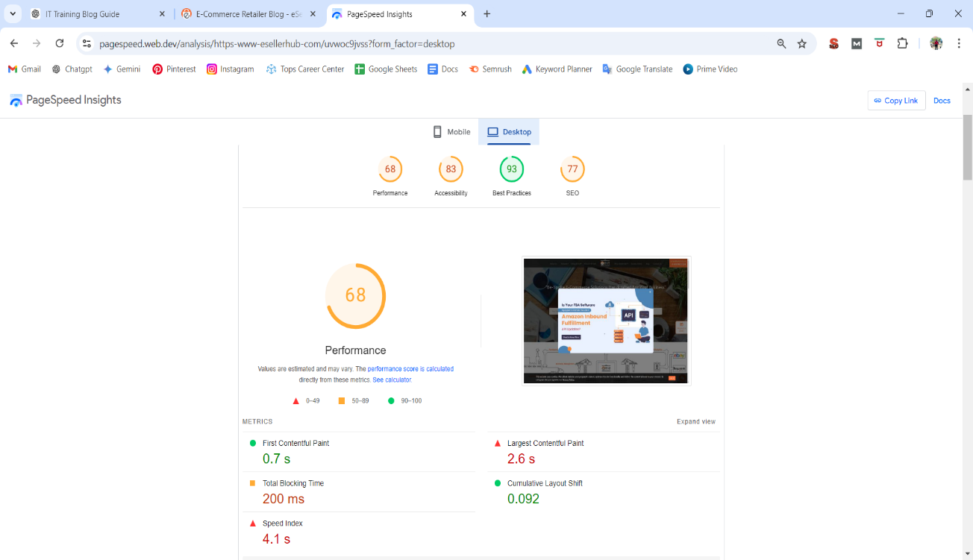

* **Improve Largest Contentful Paint**
* **Improve Website Speed**

1. **Crawling Date : 22-08-2024, 12:25:12**
2. **Schema Use**

* **Product Schema**
* **FAQ Schema**
* **Review Schema**
* **Localbussiness Schema**
* **Breadcrumb Schema**
* **OFF PAGE :-**
* Link building, Social Media Engagement, Online Reviews, Social Bookmarking, Podcast & Webinars, Blog Commenting.